## modules table

## Fields

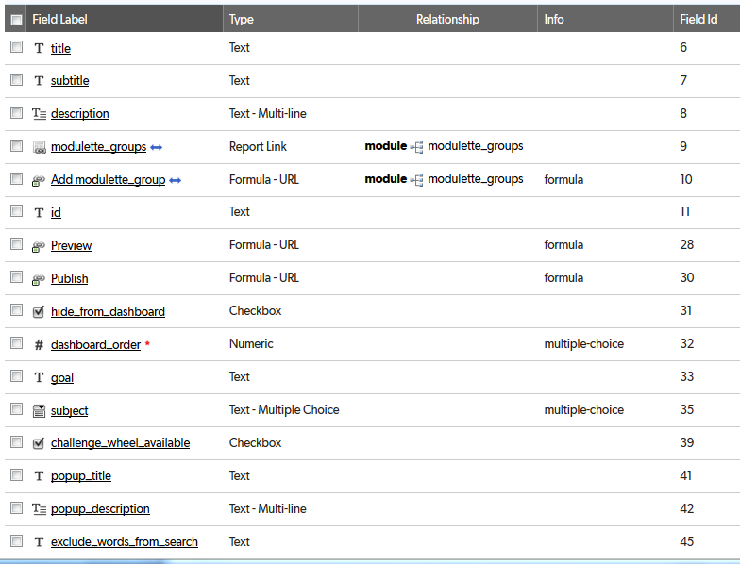

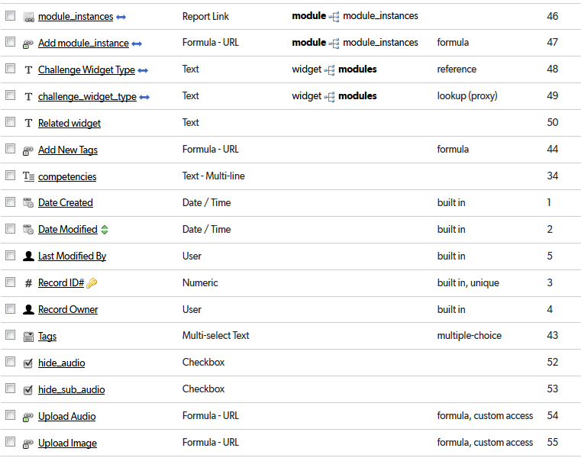  
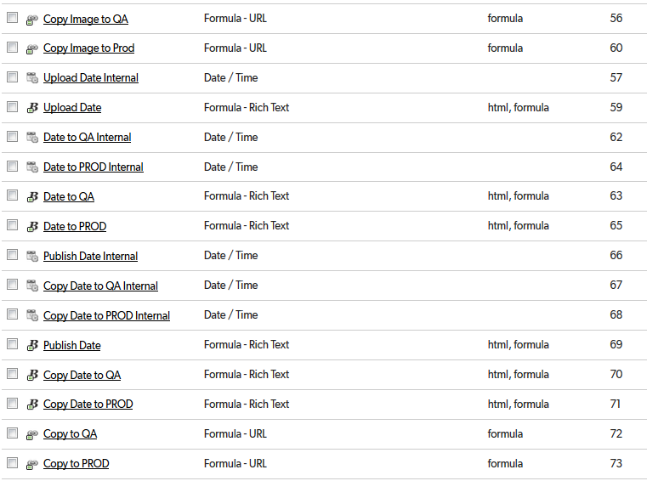

## Relationships

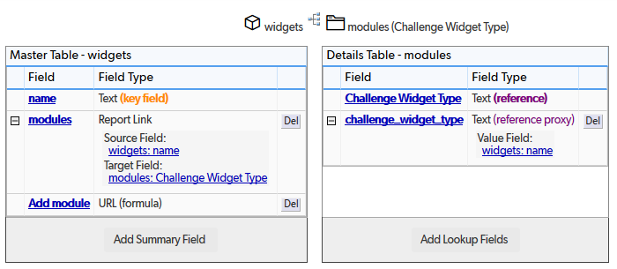

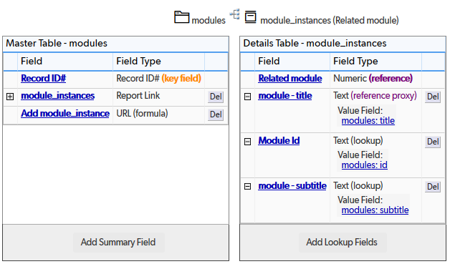

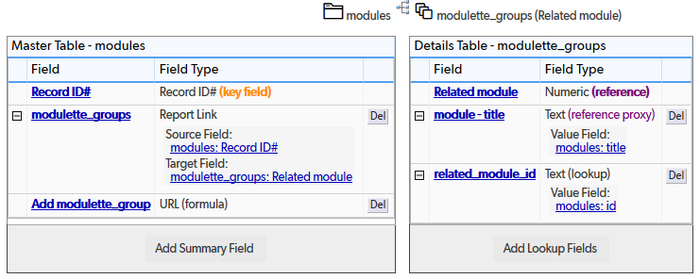

## Field settings

Note: Built-in fields use the default settings

title 6

subtitle 7

description 8

modulette_groups 9

Add modulette_group 10

id 11

Preview 12

Publish 13

hide_from_dashboard 14

dashboard_order 15

goal 17

subject 18

challenge_wheel_available 19

popup_title 20

popup_description 21

exclude_words_from_search 22

module_instances 23

Add module_instance 24

Challenge Widget Type 25

challenge_widget_type 26

Related widget 27

Add New Tags 28

competencies 29

Tags 30

hide_audio 31

hide_sub_audio 32

Upload Audio 32

Upload Image 34

Copy Image to QA 35

Copy Image to Prod 36

Upload Date Internal 37

Upload Date 38

Date to QA Internal 39

Date to PROD Internal 40

Date to QA 41

Date to PROD 41

Publish Date Internal 42

Copy Date to QA Internal 43

Copy Date to PROD Internal 44

Publish Date 45

Copy Date to QA 46

Copy Date to PROD 47

Copy to QA 47

Copy to PROD 48

# title

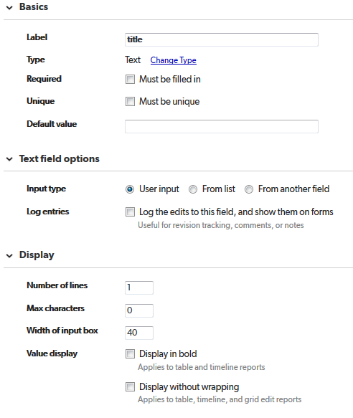

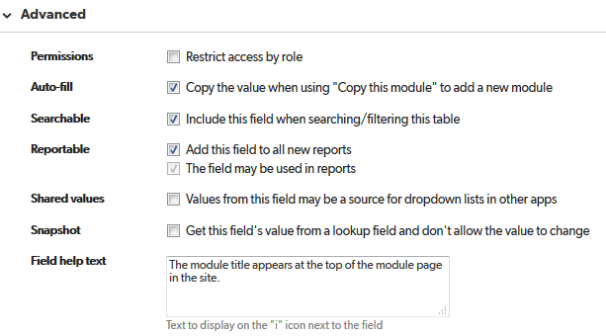

# subtitle

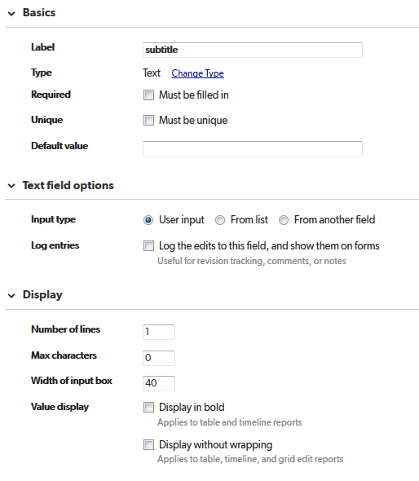

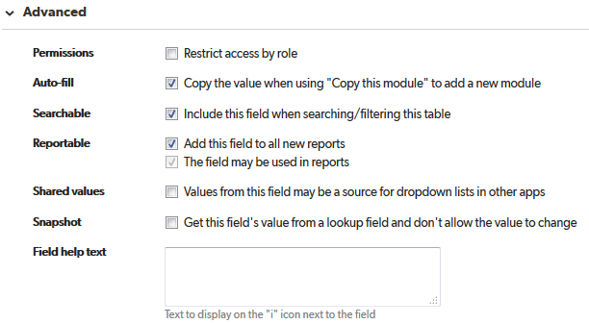

# description

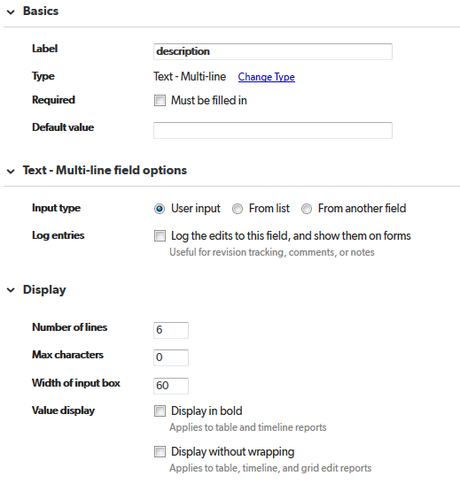

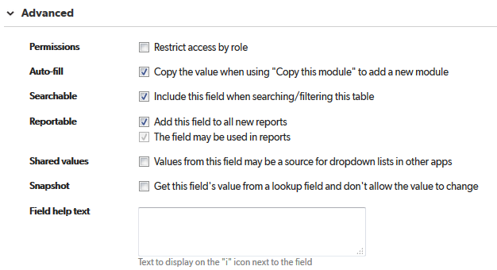

# modulette_groups

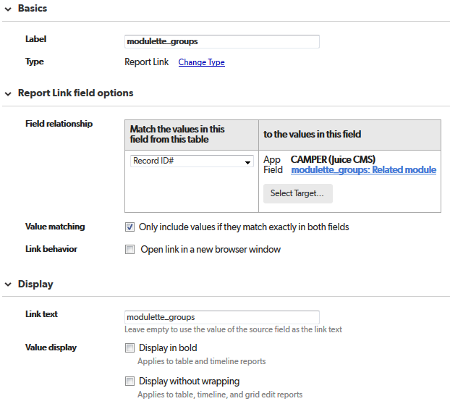

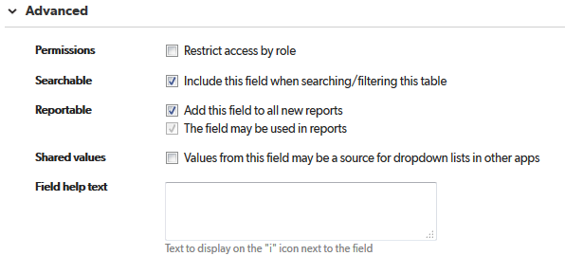

# Add modulette_group

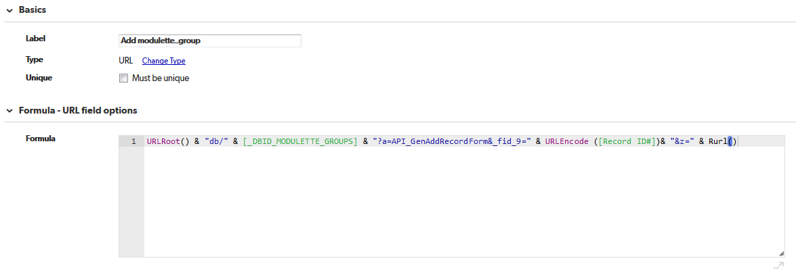

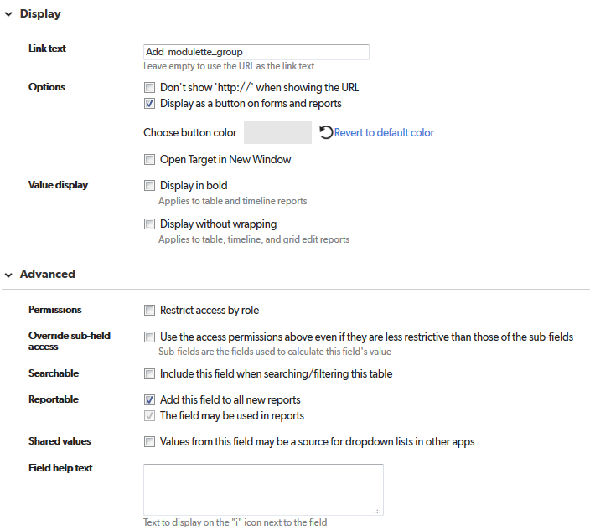

# id

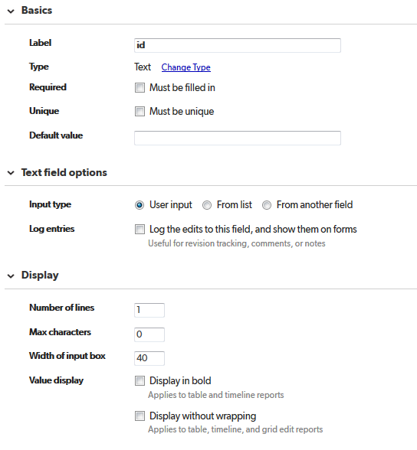

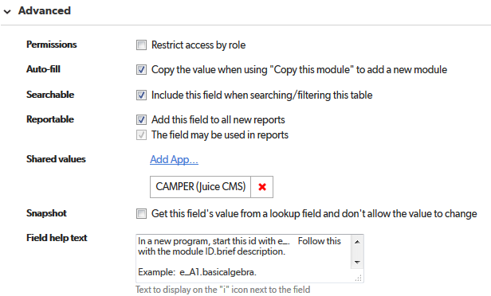

# Preview

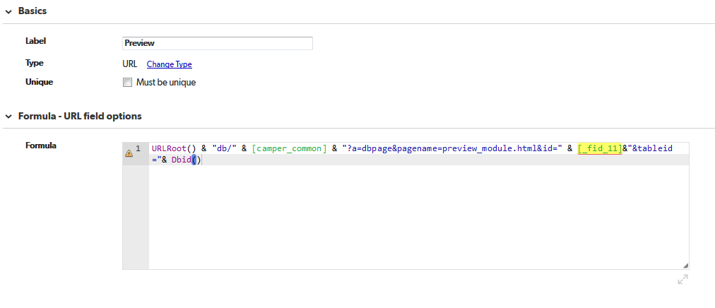

URLRoot() & "db/" & [camper_common] & "?a=dbpage&pagename=preview_module.html&id=" & [_fid_11]&"&tableid="& Dbid()

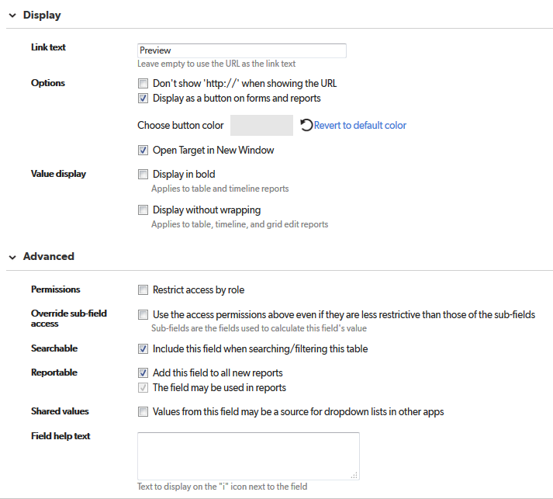

# Publish

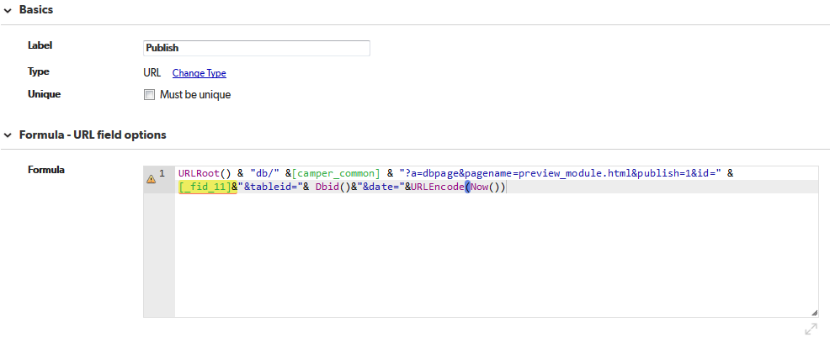

URLRoot() & "db/" &[camper_common] & "?a=dbpage&pagename=preview_module.html&publish=1&id=" & [_fid_11]&"&tableid="& Dbid()&"&date="&URLEncode(Now())

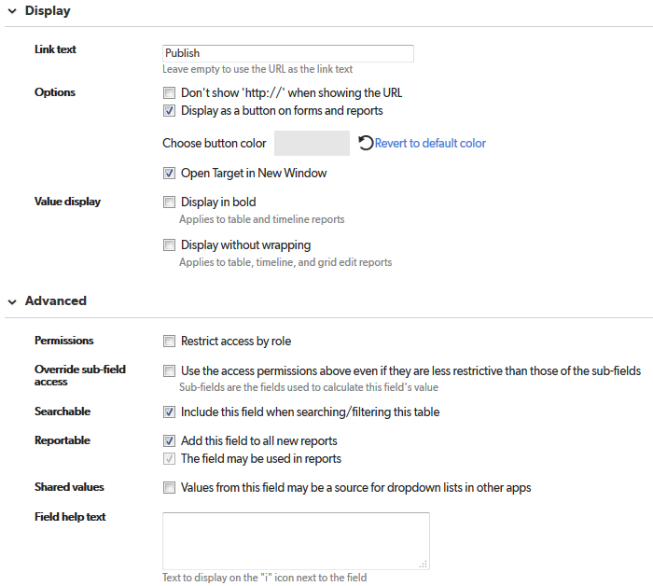

# hide_from_dashboard

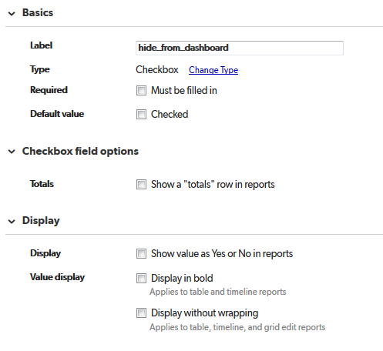

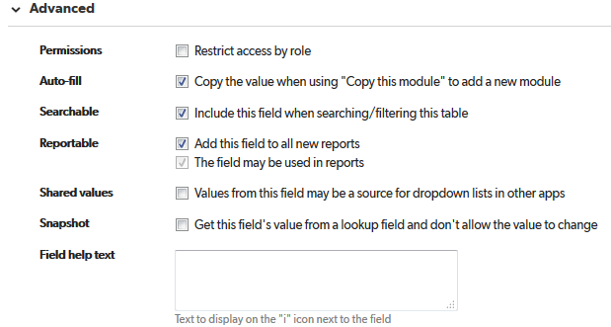

# dashboard_order

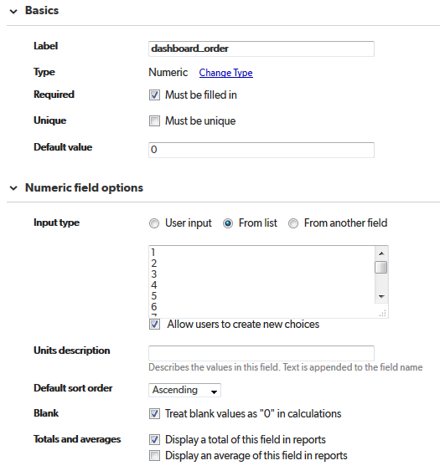

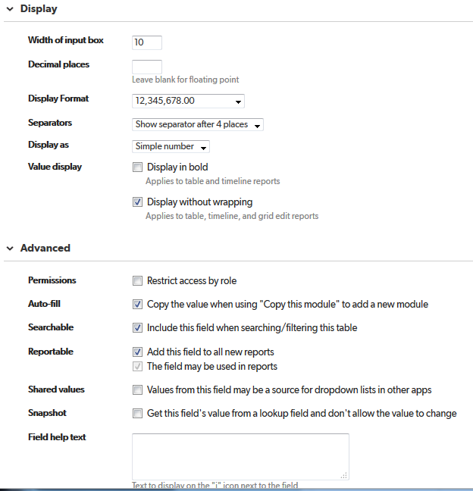

# goal

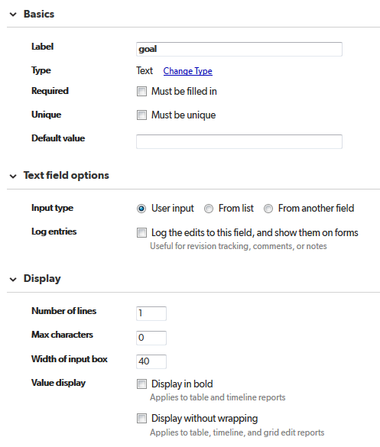

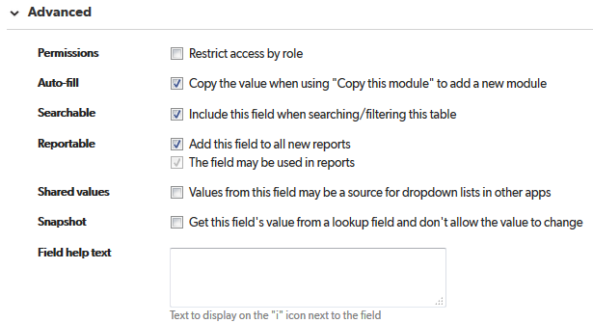

# subject

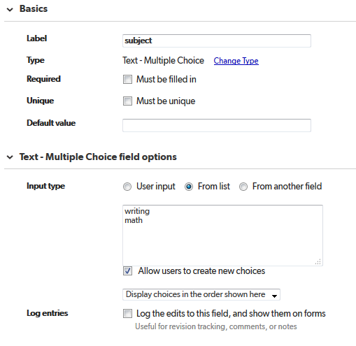

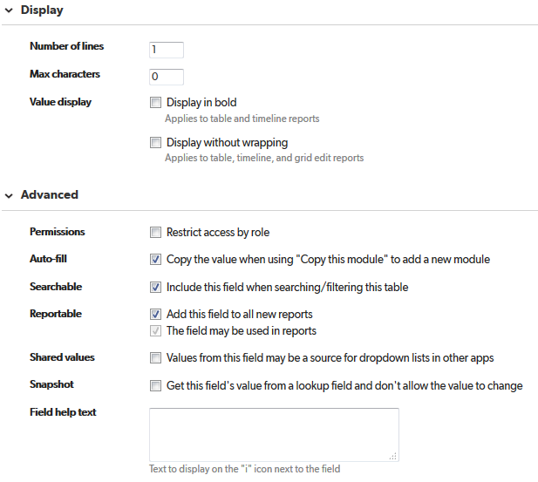

# challenge_wheel_available

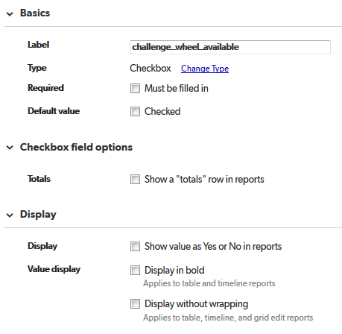

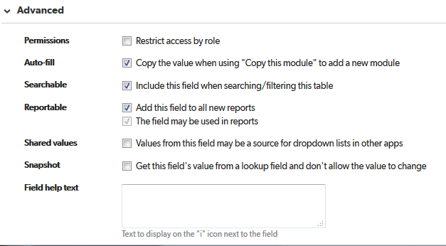

# popup_title

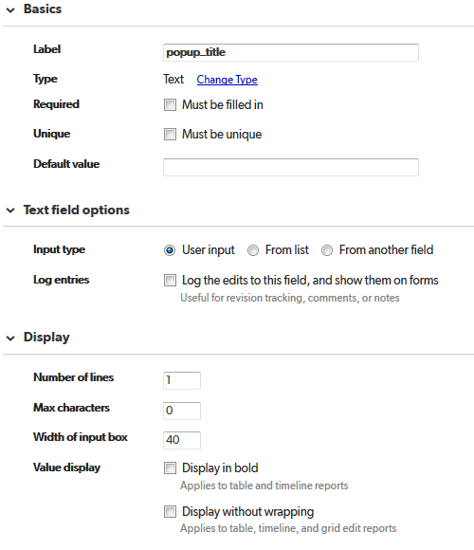

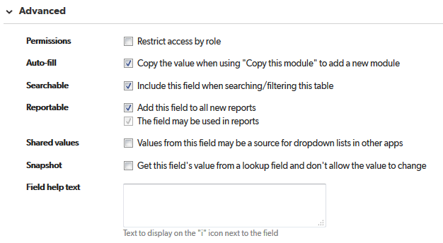

# popup_description

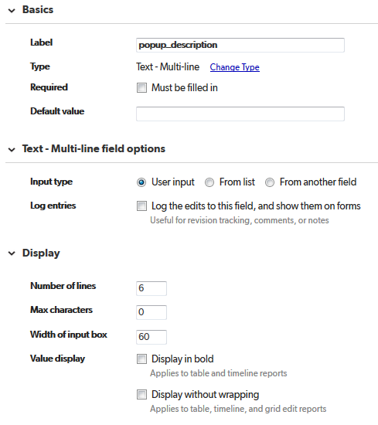

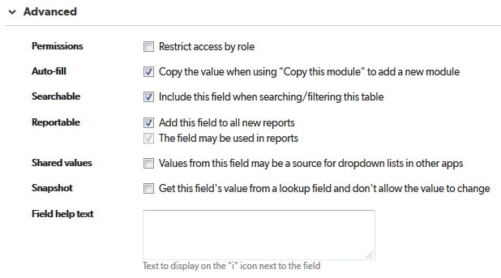

# exclude_words_from_search

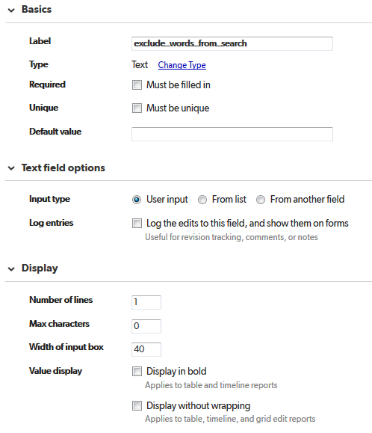

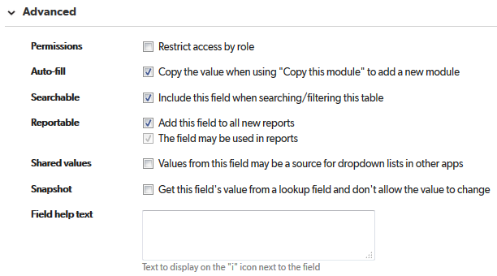

# module_instances

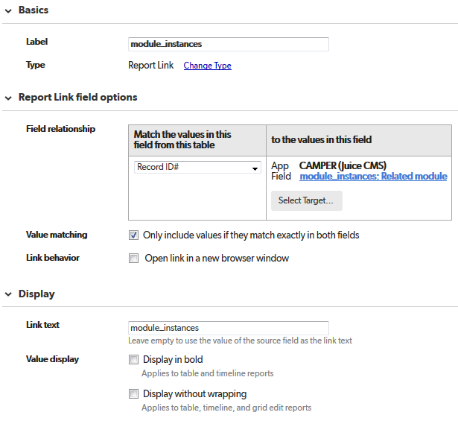

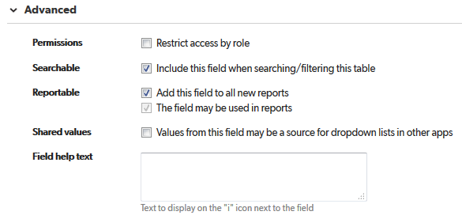

# Add module_instance

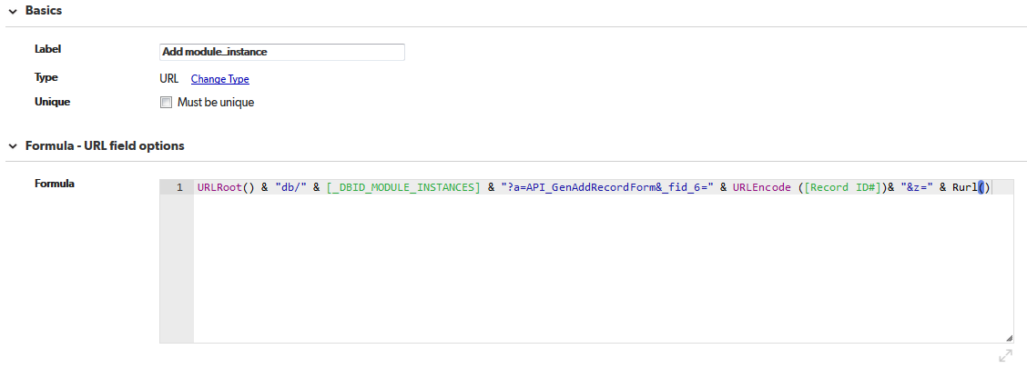

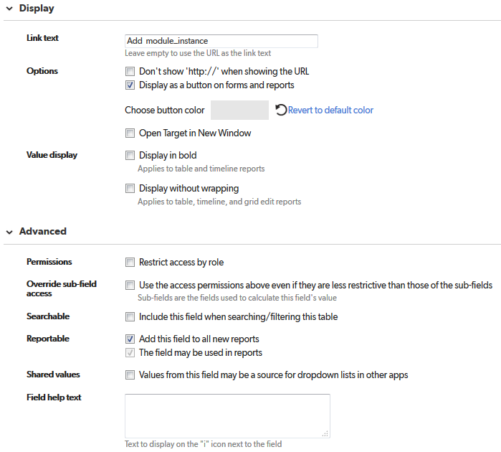

# Challenge Widget Type

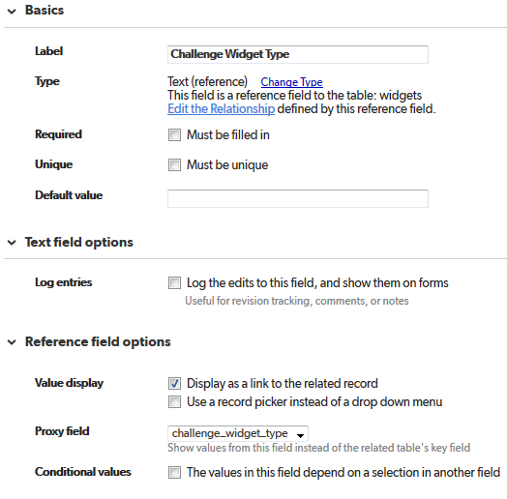

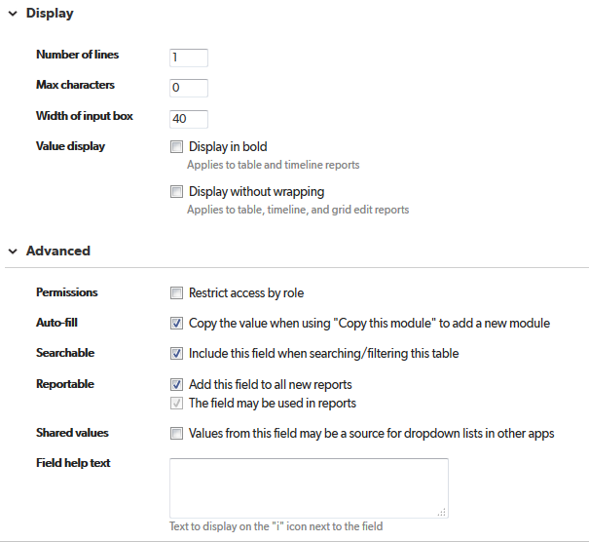

# challenge_widget_type

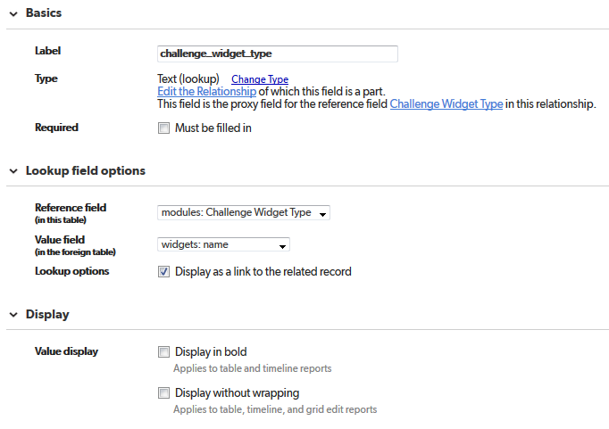

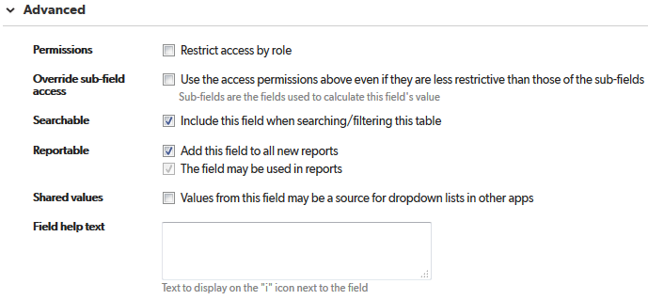

# Related widget

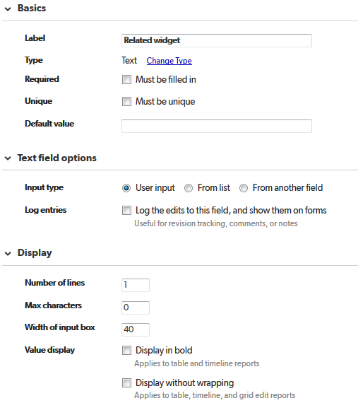

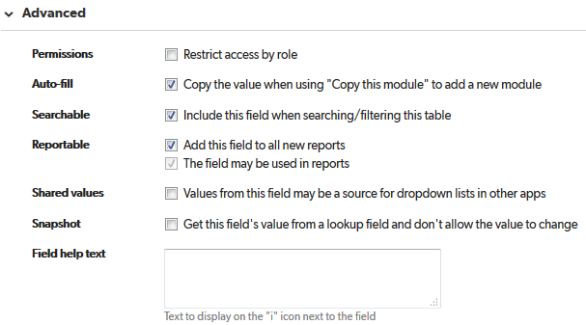

# Add New Tags

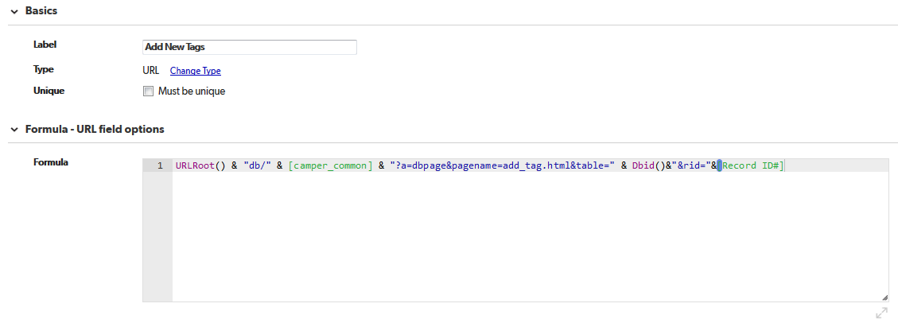

URLRoot() & "db/" & [camper_common] & "?a=dbpage&pagename=add_tag.html&table=" & Dbid()&"&rid="&[Record ID#]

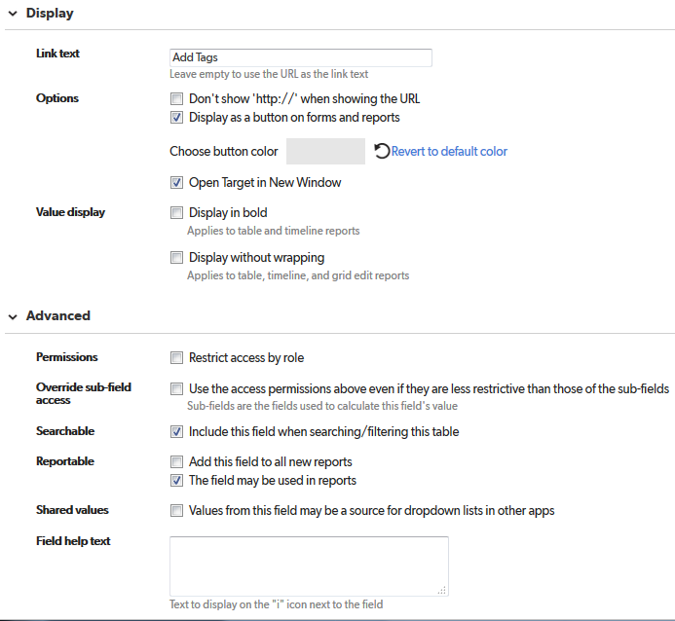

# competencies

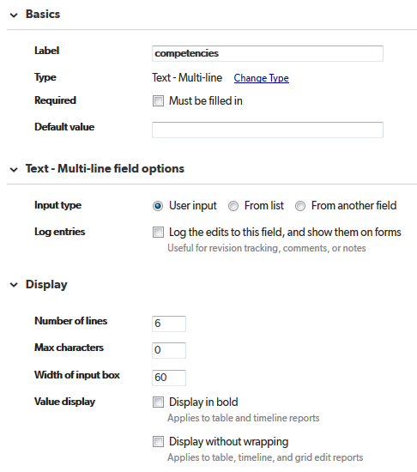

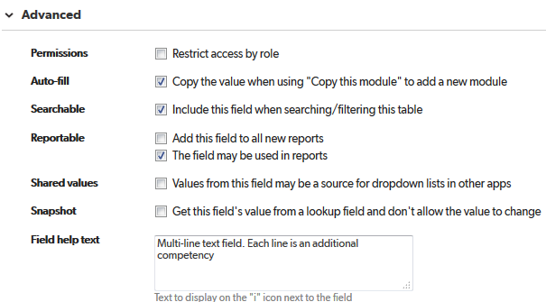

# Tags

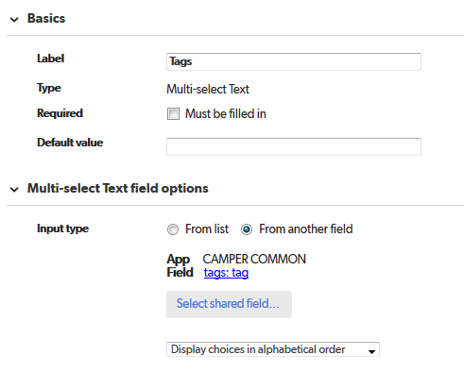

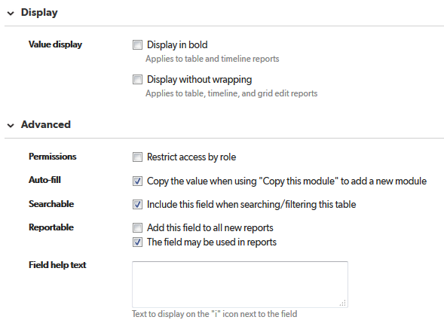

# hide_audio

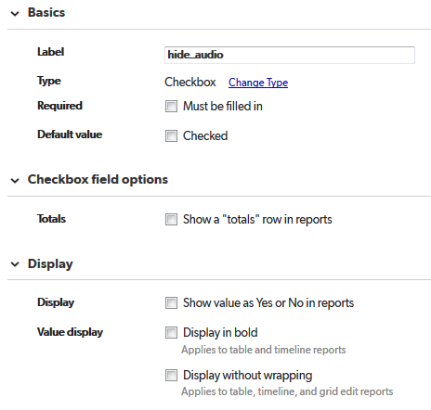

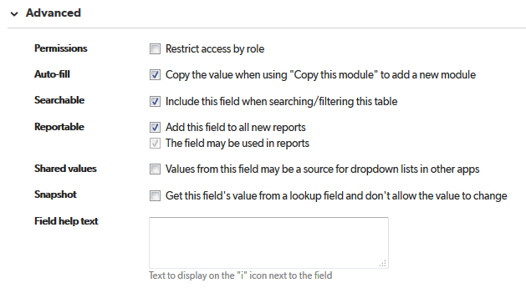

# hide_sub_audio

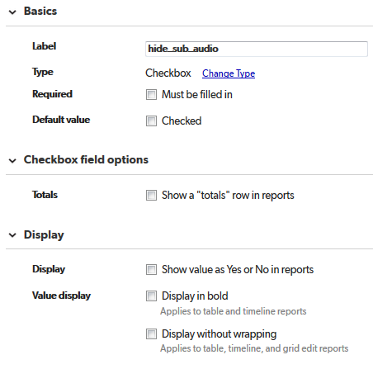

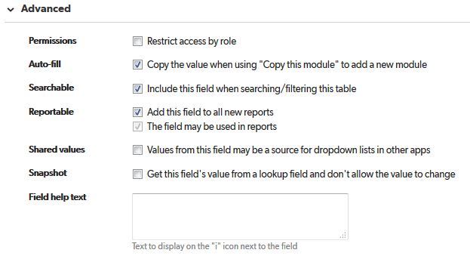

# Upload Audio

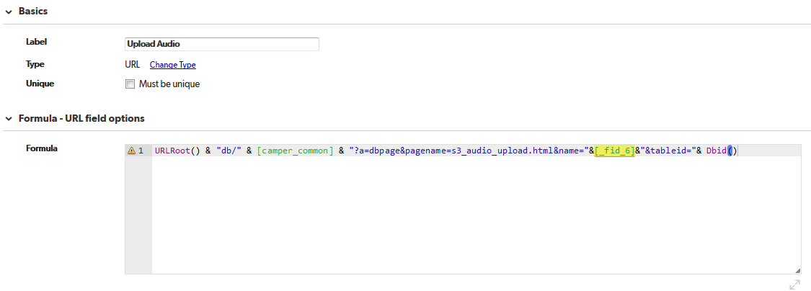

URLRoot() & "db/" & [camper_common] & "?a=dbpage&pagename=s3_audio_upload.html&name="&[_fid_6]&"&tableid="& Dbid()

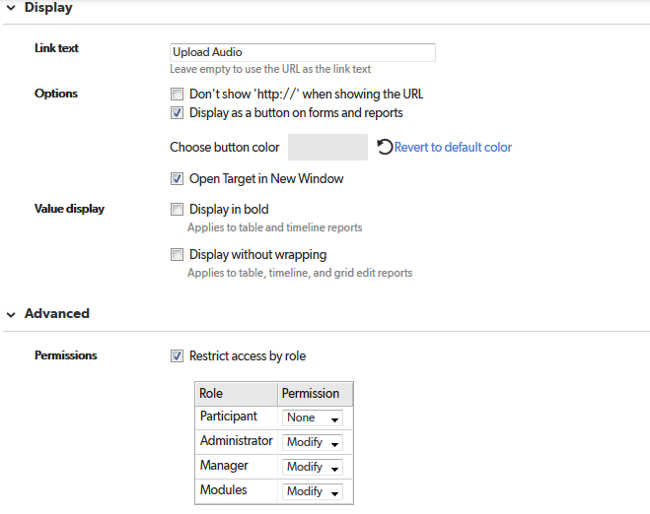

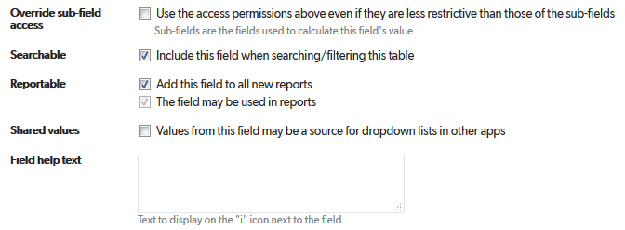

# Upload Image

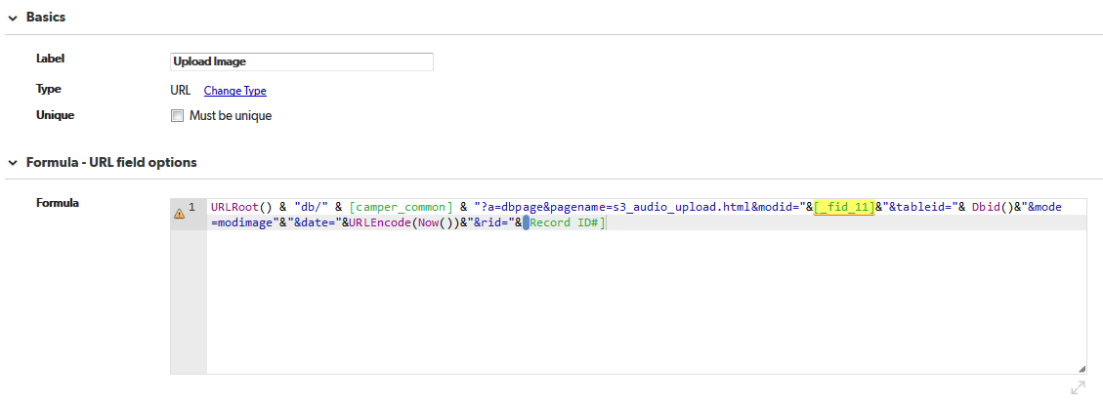

URLRoot() & "db/" & [camper_common] & "?a=dbpage&pagename=s3_audio_upload.html&modid="&[_fid_11]&"&tableid="& Dbid()&"&mode=modimage"&"&date="&URLEncode(Now())&"&rid="&[Record ID#]

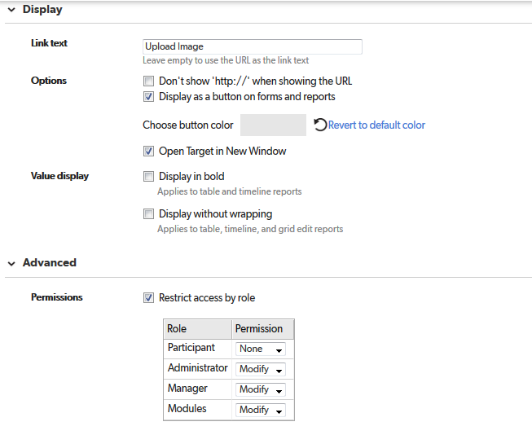

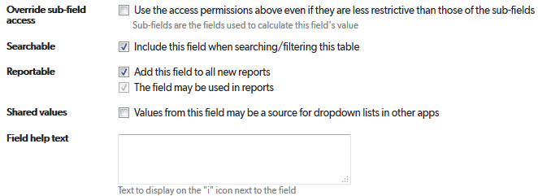

# Copy Image to QA

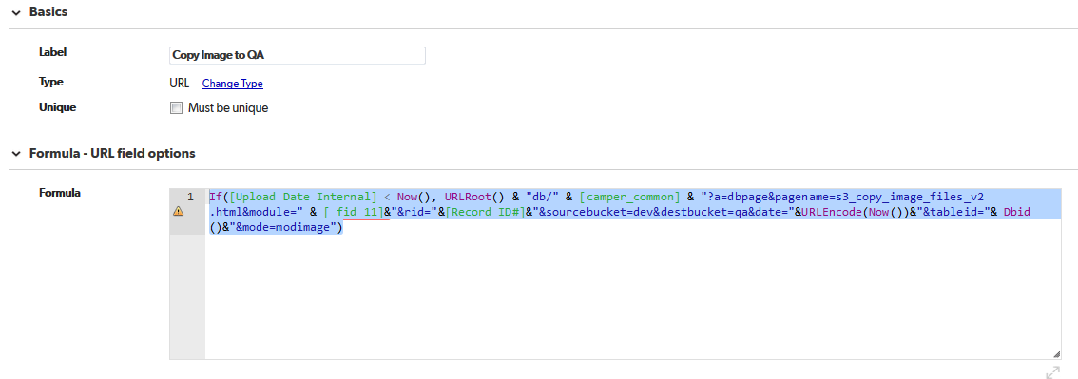

If([Upload Date Internal] < Now(), URLRoot() & "db/" & [camper_common] & "?a=dbpage&pagename=s3_copy_image_files_v2.html&module=" & [_fid_11]&"&rid="&[Record ID#]&"&sourcebucket=dev&destbucket=qa&date="&URLEncode(Now())&"&tableid="& Dbid()&"&mode=modimage")

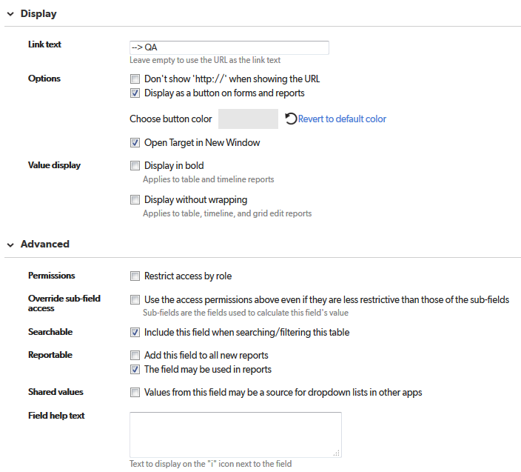

# Copy Image to Prod

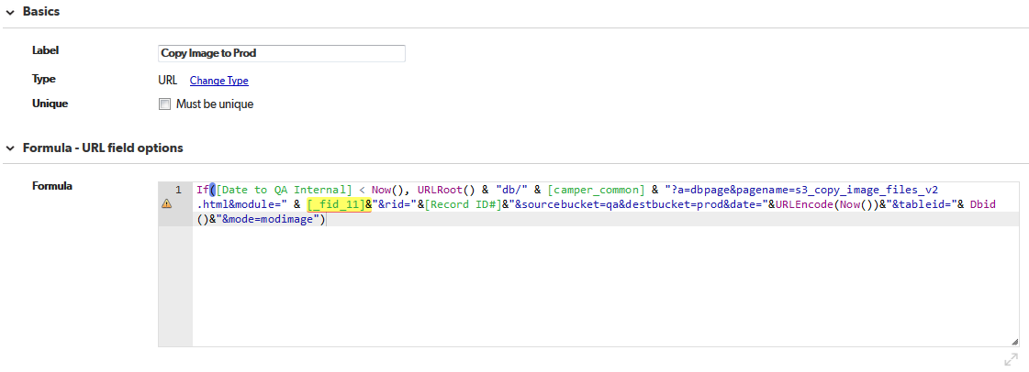

If([Date to QA Internal] < Now(), URLRoot() & "db/" & [camper_common] & "?a=dbpage&pagename=s3_copy_image_files_v2.html&module=" & [_fid_11]&"&rid="&[Record ID#]&"&sourcebucket=qa&destbucket=prod&date="&URLEncode(Now())&"&tableid="& Dbid()&"&mode=modimage")

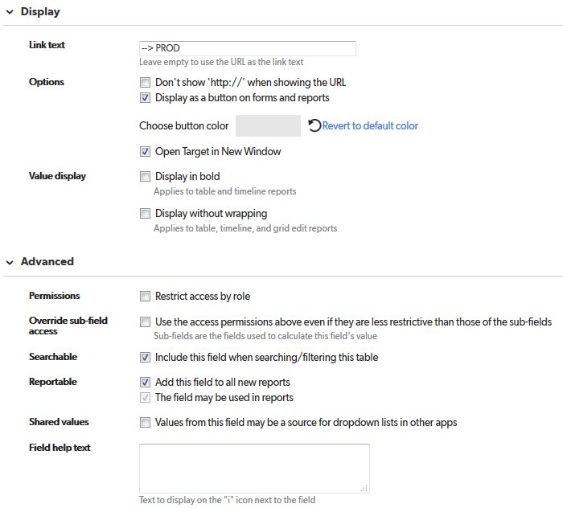

# Upload Date Internal

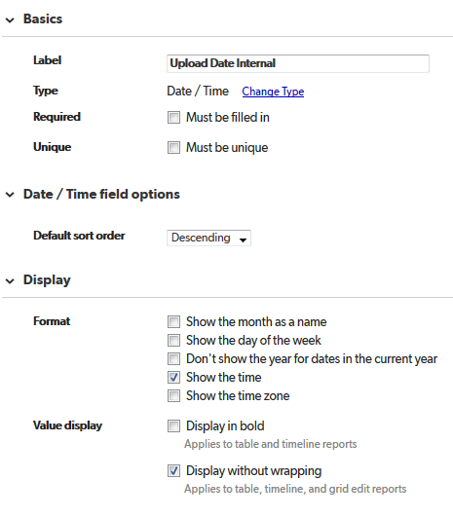

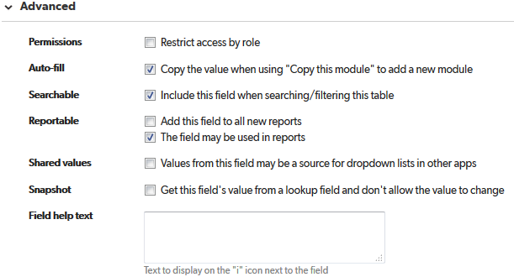

# Upload Date

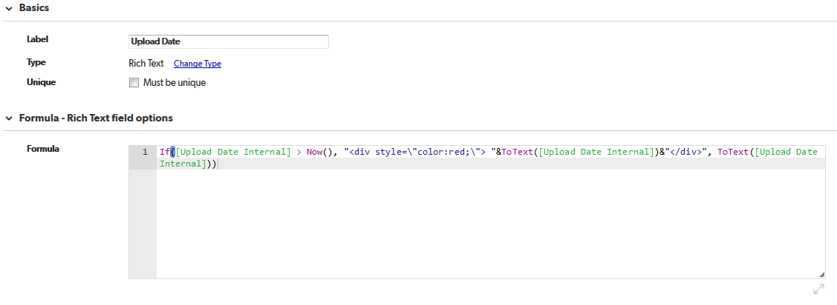

If([Upload Date Internal] > Now(), "<div style=\"color:red;\"> "&ToText([Upload Date Internal])&"</div>", ToText([Upload Date Internal]))

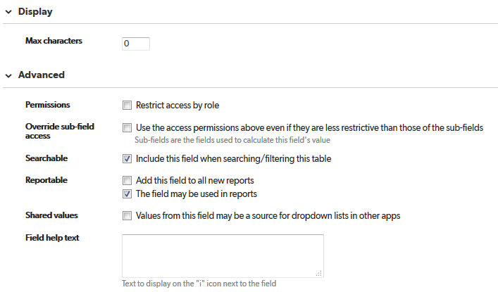

# Date to QA Internal

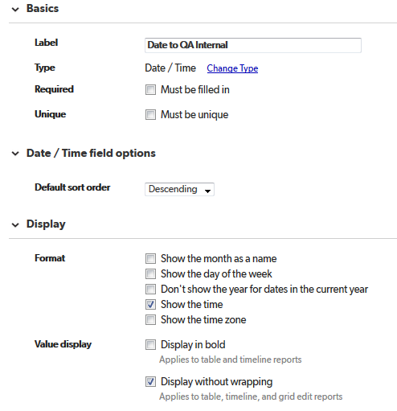

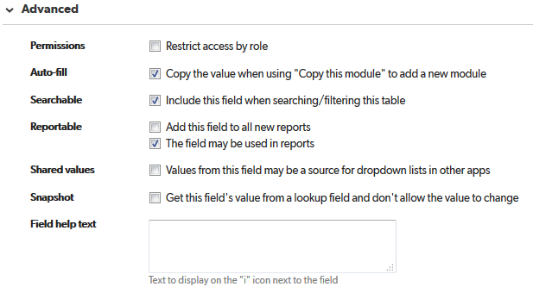

# Date to PROD Internal

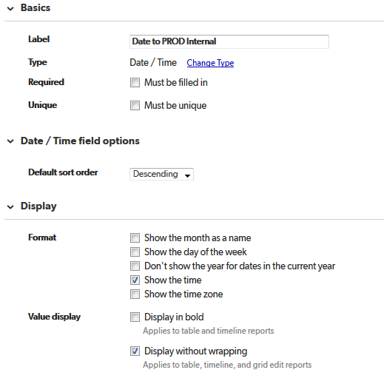

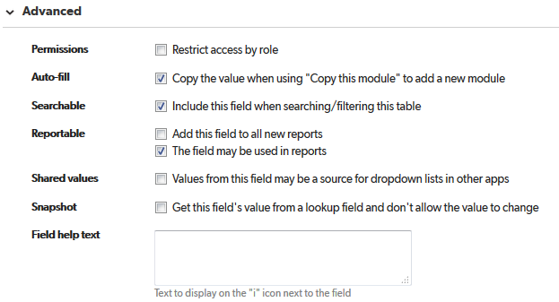

# Date to QA

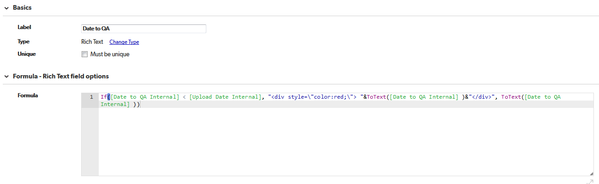

If([Date to QA Internal] < [Upload Date Internal], "<div style=\"color:red;\"> "&ToText([Date to QA Internal] )&"</div>", ToText([Date to QA Internal] ))

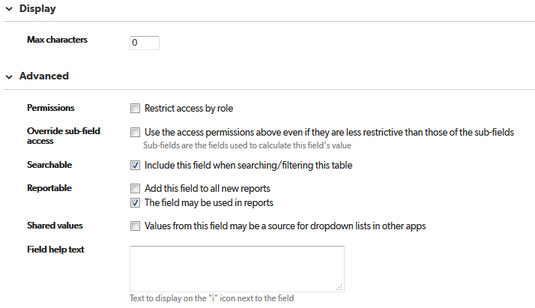

# Date to PROD

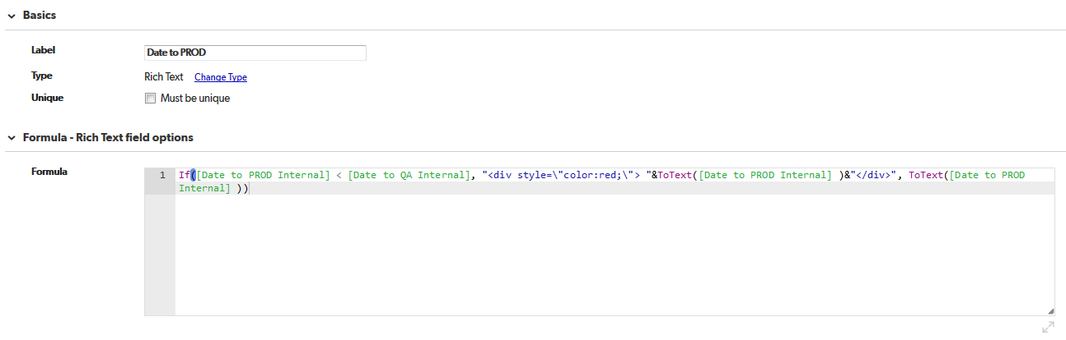

If([Date to PROD Internal] < [Date to QA Internal], "<div style=\"color:red;\"> "&ToText([Date to PROD Internal] )&"</div>", ToText([Date to PROD Internal] ))

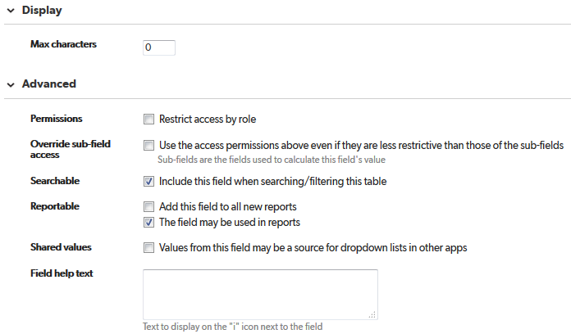

# Publish Date Internal

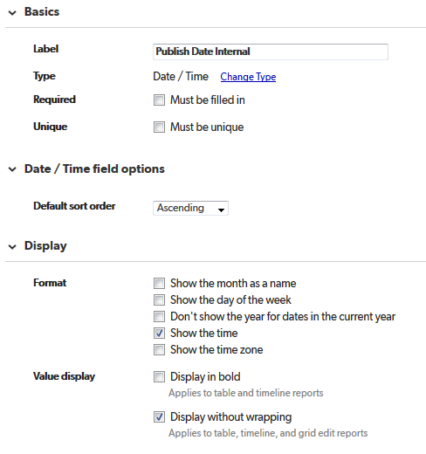

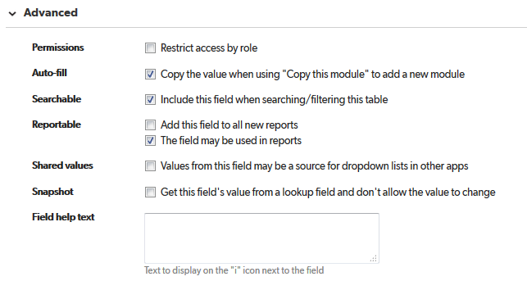

# Copy Date to QA Internal

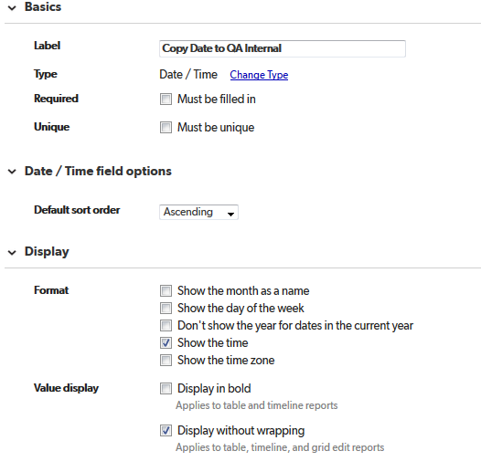

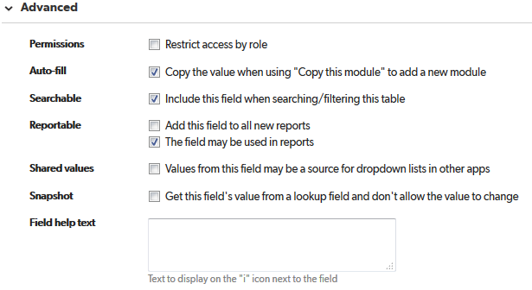

# Copy Date to PROD Internal

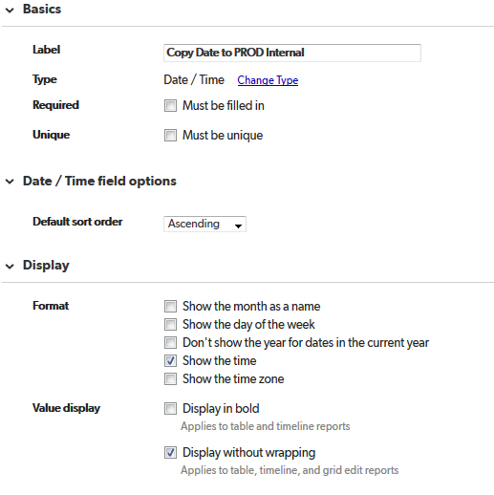

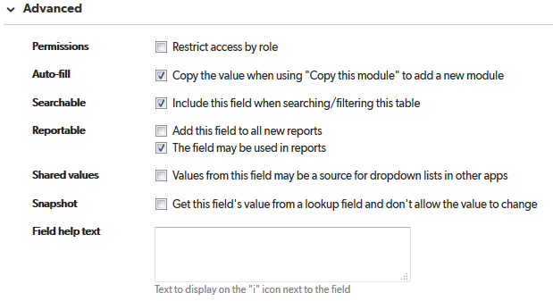

# Publish Date

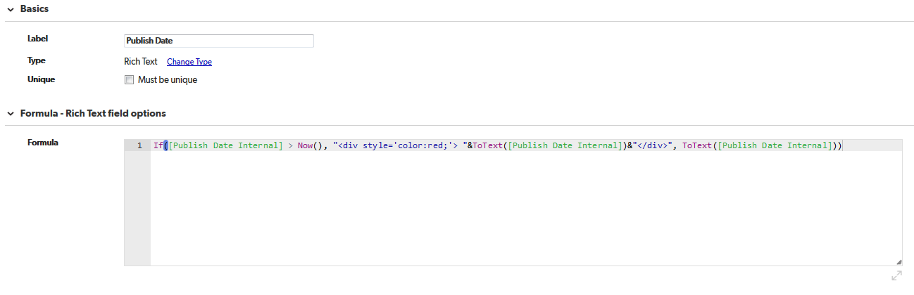

If([Publish Date Internal] > Now(), "<div style='color:red;'> "&ToText([Publish Date Internal])&"</div>", ToText([Publish Date Internal]))

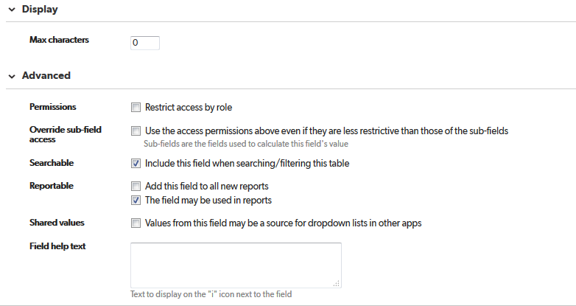

# Copy Date to QA

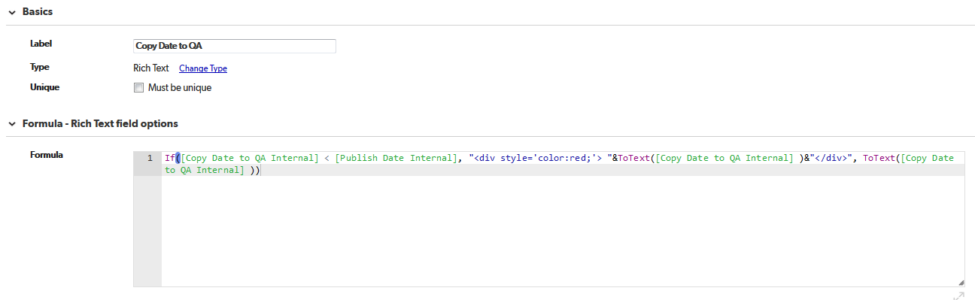

If([Copy Date to QA Internal] < [Publish Date Internal], "<div style='color:red;'> "&ToText([Copy Date to QA Internal] )&"</div>", ToText([Copy Date to QA Internal] ))

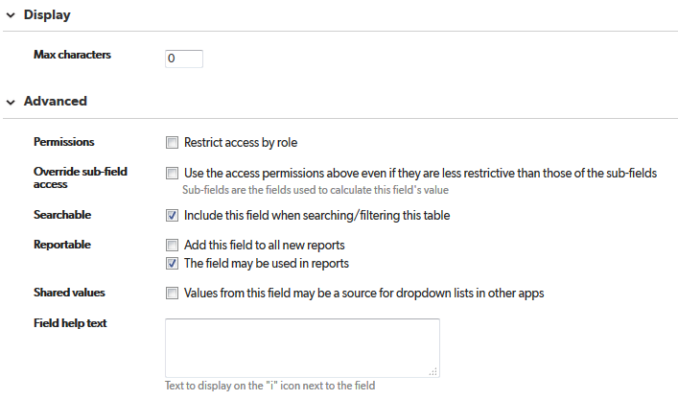

# Copy Date to PROD

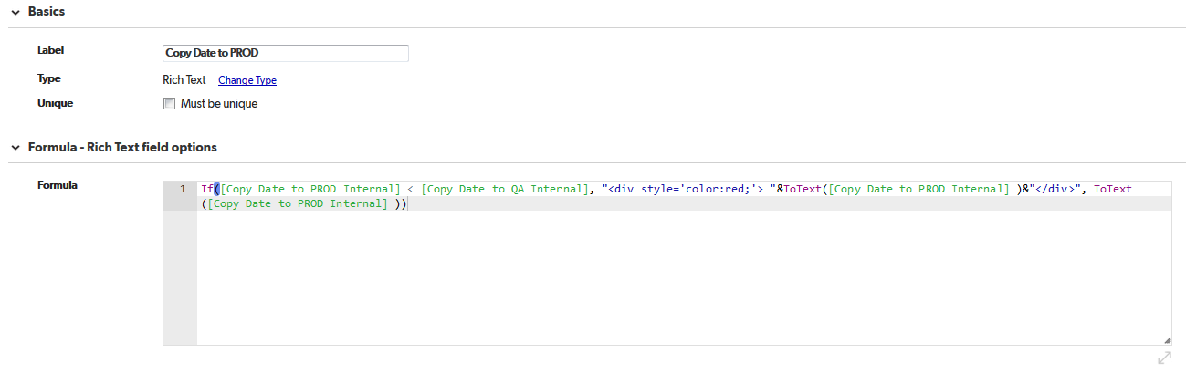

If([Copy Date to PROD Internal] < [Copy Date to QA Internal], "<div style='color:red;'> "&ToText([Copy Date to PROD Internal] )&"</div>", ToText([Copy Date to PROD Internal] ))

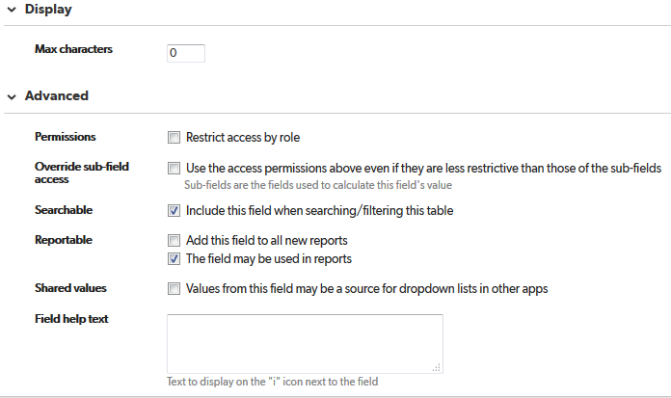

# Copy to QA

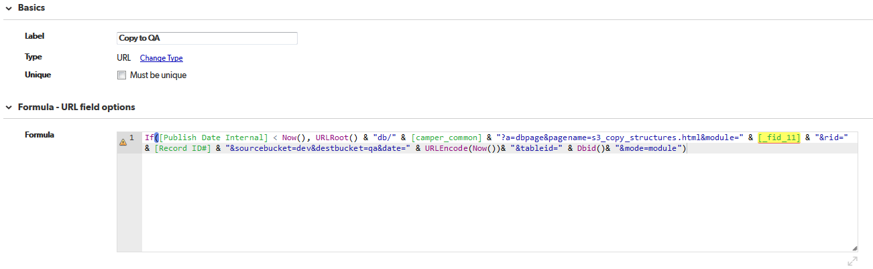

If([Publish Date Internal] < Now(), URLRoot() & "db/" & [camper_common] & "?a=dbpage&pagename=s3_copy_structures.html&module=" & [_fid_11] & "&rid=" & [Record ID#] & "&sourcebucket=dev&destbucket=qa&date=" & URLEncode(Now())& "&tableid=" & Dbid()& "&mode=module")

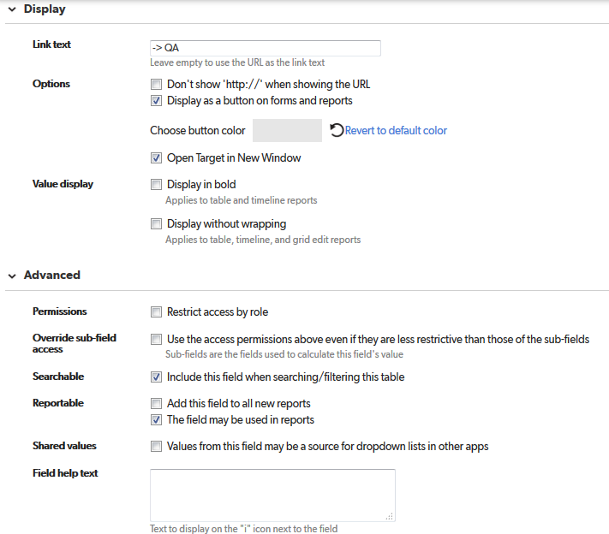

# Copy to PROD

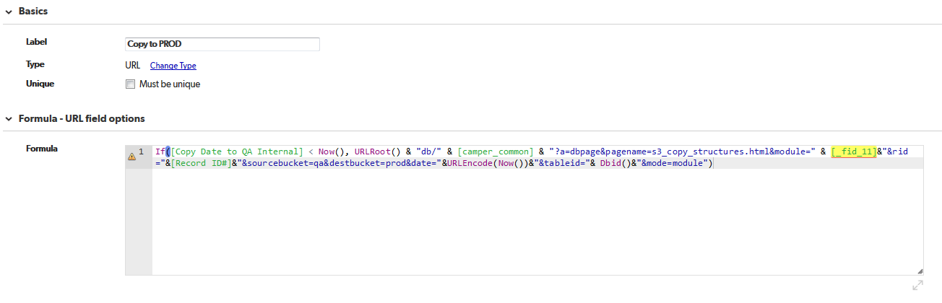

If([Copy Date to QA Internal] < Now(), URLRoot() & "db/" & [camper_common] & "?a=dbpage&pagename=s3_copy_structures.html&module=" & [_fid_11]&"&rid="&[Record ID#]&"&sourcebucket=qa&destbucket=prod&date="&URLEncode(Now())&"&tableid="& Dbid()&"&mode=module")

